UX DESIGN

S3

Welles,Nick n.h.m.

2022-2023

Table of content

What is UX Design 1

5 steps of UX Design 1

Product definition 1

Research 1

Analysis 2

# What is UX Design

UX design is the most common way of designing (digital or physical) items that are valuable, simple to utilize, and superb to associate with. About upgrading the experience individuals have while connecting with your item, and ensuring they find esteem in the thing you're giving.

Source: <https://www.usertesting.com/blog/what-is-ux-design-15-user-experience-experts-weigh-in>

## 5 steps of UX Design

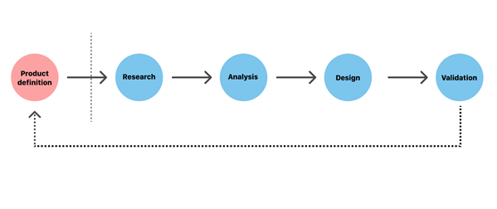

### Product definition

What is really significant in making the product is grasping the product. Who is it for? For what reason does it exist? Who are the clients? What is the main data for the client? This is in many cases talked about by the group as a team with the partners.

Instruweb:  
Instruweb is an online shop where you can order music instruments and such for your hobby, and/or professional use.

### Research

An important part of understanding why customers choose a new product is doing research. This can be done through a survey/interview that you can conduct with the customer. You could also research what similar products already exist.

Since I am my own client, I naturally asked the questions to myself, but this all happens while building the product. It is difficult to estimate yourself in terms of UX.

Most of the questions I have already answered in the requirements that you can find in the [Software Design](Software%20design.docx) document.

### Analysis

Once the requirements are known and everyone knows what the product is supposed to do, the creation of a design can begin. This is done in several steps. It starts with a sketch, then you start making wireframes and then prototypes.

Sketch:

Wireframe:

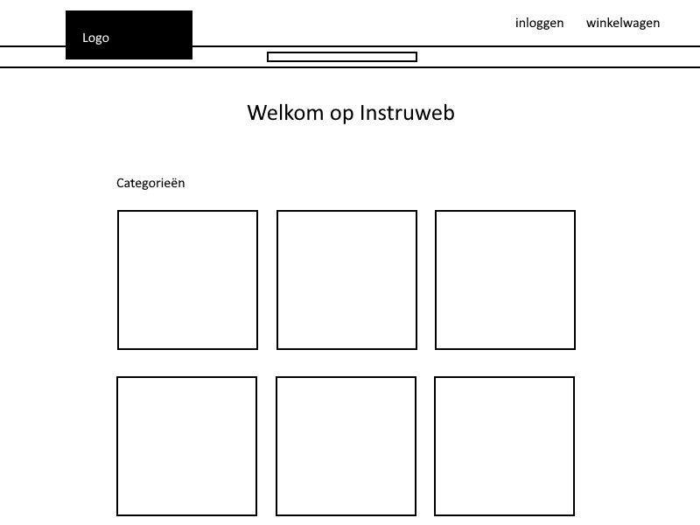

Prototype:

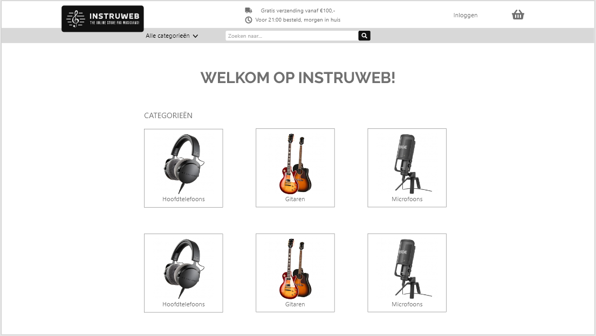

The complete prototype and UX flow can be found in the Adobe XD file.

[View file](Instruweb.xd)